Cricket Blast School Cup Year 9& 10 Boys Rules

THE GAME
- Each game is played between two teams with a minimum of eight players. Substitutes may be used in any combination providing that no more than eight individuals bat and eight individuals bowl. Only eight fielders are permitted on the field at any one time.
- At regional carnivals teams will play a minimum of three round robin games. There will also be a final to decide the winning boys and girls team.
- A coin toss is used to decide which team bats first in each game.
- A team must have at least 6 players to participate in a match. If a team has 6 or 7 players, the opposition team will nominate 3 players who cannot bat twice and 3 players that cannot bowl twice. This will be decided after the third pair of batters/bowlers have completed their overs.

EQUIPMENT
- Wooden or plastic bats may be used by batters.
- Kookaburra ‘Softa balls’ will be used at regional carnivals and are provided by Cricket Victoria.
- All batters must wear pads and gloves.
- It is strongly recommended that the batters and wicket-keeper wear a helmet with a grill.

BATTING
- Each team is allowed eight batters. Player one and two bat first for the batting side. Players bat until they are ‘out’ or their individual score reaches 25 when they must retire. A batter who has retired can return to bat once all other batters have been ‘out’.
- Players can be ‘out’ in the following ways: ‘bowled’, ‘caught’, ‘run out’, ‘stumped’, ‘hit wicket’ or ‘leg before wicket’ (L.B.W). A batter can only be out L.B.W. when they do not offer a shot and the ball is definitely going to hit the stumps.
- When a batter is ‘out’ they are replaced by the next listed batter. The bowling team do not receive any bonus runs for taking a wicket.
- The batting innings concludes once all batters are dismissed or at the conclusion of eight overs.
- If runs are hit into the double zone, any overthrows are not doubled

BOWLING
- Eight overs must be bowled by each team. Each player is to bowl one over. The team can decide to have a ‘designated wicket-keeper’ who does not bowl. The eighth over can be bowled by a player who has previously bowled one over.
- Bowlers are limited to eight metre run-ups. The maximum run up will be marked by a white line.
- All overs are bowled from the same end. At the end of each over the batters swap ends.

- There will be a maximum of six deliveries in each over. ‘No balls’ are not re-bowled except for the final over of the innings, which must contain six legitimate balls.

NO BALLS
- A ball that bounces over shoulder height when the batter is in a normal batting stance shall be called a ‘no ball’. Any ball that is a full toss above waist height shall also be deemed a ‘no ball’.
- At the batter’s end there will be two plastic cones parallel to the stumps, 120 cms from the middle stump. Any ball that passes outside this area shall be deemed a ‘no ball’. (See Diagram A).
- Two runs are awarded to the batting team for every ‘no ball’ bowled.
- Any over-arm delivery that bounces more than once or rolls along the ground, shall be deemed a fair delivery (unless the bowler is deliberately rolling it along the ground to obviously gain an advantage). THE UMPIRE MAY DECIDE TO REBOWL DELIVERIES IF CONSIDERED UNFAIR.
- If an above waist full toss no ball is bowled the batter will receive any runs scored plus 2 extras.

FREE HIT
- If a ‘no ball’ is bowled the next ball is a ‘free hit’. Batters can only be ‘out’ from being ‘run out’ from a ‘free hit’. They can’t be ‘bowled’, ‘hit wicket’ ‘leg before wicket’ or ‘stumped’.
- If a batter hits a delivery that is a ‘no ball’, they score two plus whatever runs are scored from the shot. The next ball remains a FREE HIT BALL. If the batter decides to leave or misses a delivery that is deemed a ‘no ball’, they score two runs for the ‘no ball’ and the next ball is a
free hit.
- If a batter decides to hit a delivery (and connects) that is wide of the ‘no ball’ markers, they only score runs made from that shot and they may be caught out. If the batter decides to leave or misses a wide delivery, they score two runs for the ‘no ball’ plus whatever runs they score from the next ball which is a free hit.

FIELDING
- At the moment of delivery, no players may field closer than 10 metres from the bat (except for the wicketkeeper or slip fielders. (See Diagram B).
- No more than three players can field in the ‘double zone’ at the time of delivery.
- Fielders can be interchanged at the conclusion of each batting pair. If a fielder is injured a substitute may take his/her place and fulfil all requirements of that player.

SCORING
- The Year 9/10 Boys scoresheet is different to the Year 7/8 & Year 9/10 Girls scoresheet.
- All runs and extras are scored according to the rules of cricket with the following exceptions.
- A ‘no ball’ is scored as two runs to the batting side plus whatever runs are scored. The next ball is a ‘free hit’.
- Any run scored off the bat into the ‘double zone’ will be doubled. The ‘double zone’ is any area behind the stumps at the bowler’s end. (See Diagram B & C). A ball hit along the ground to the boundary in this zone, is credited with eight runs. If the ball is hit over the boundary on the full in the ‘double zone’, then 12 runs are scored. (Note: two runs for a ‘no ball’ does not become four if it is hit into the double zone).
- Teachers, parents or helpers from both teams will be responsible for scoring at all games.
Teachers, parents, helpers or local cricket club members will help umpire regional carnivals.
- If teams are tied on points and runs scored after round 3, final ladder positions will be decided by:
  - If the teams have played each other previously the winning team will finish the higher placed team
  - If teams have not played each other, the higher placed team will be decided by a bowl-off - If a bowl-off is not possible, the team that has taken the most wickets will be the higher p placed team

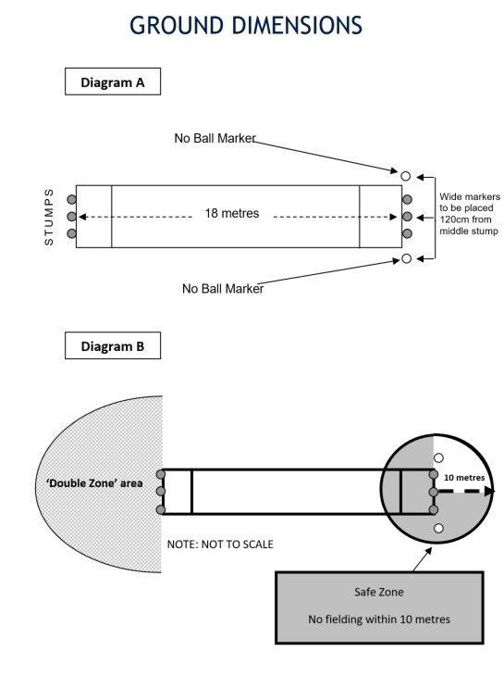

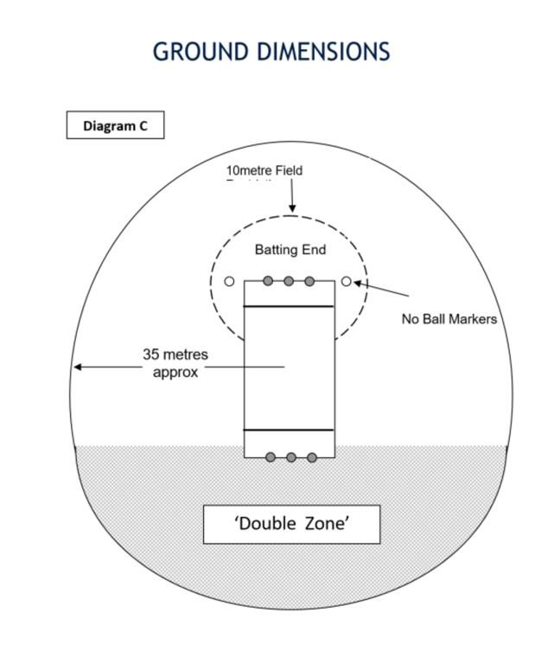

NB: This may need to be adjusted based on the space available, ensure all grounds within the same competition have the same field size.

