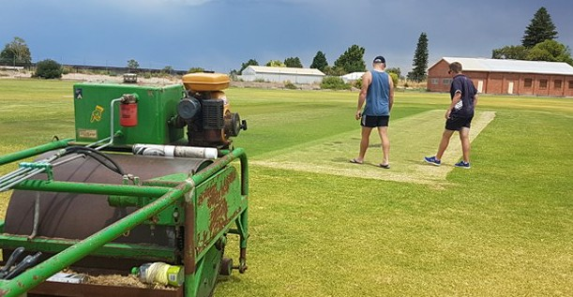
CLUB CURATOR TRAINING

DONALD RECREATION RESERVE

Hands-on training with Pitchcraft’s Liam Kirkman, aimed at volunteer curators to provide guidance in managing turf pitches and cricket grounds.

Sunday, 22 September 2019
9:00am - 12:00 midday
Donald Recreation Reserve, Donald
No cost to attend, registration required.

Topics to be covered include:
Maximising your time;
Getting the best out of your wicket;
Machinery & equipment;
Repair & maintenance;
Planning & scheduling;
Fertilisers, weeding and soil
Use of growth mats and covers
Practical sessions working on actual centre wickets

For more information please contact Annie Hateley 03 9085 4046 or ahateley@cricketvictoria.com.au
CLICK HERE TO REGISTER

