Cricket Blast School Cup Primary Rules

RULES
- A game is played between two teams with a minimum of eight players. Substitutes may be used in any combination providing that no more than 8 individuals bat and 8 individuals bowl. Only 8 fielders are permitted on the field at any one time. Thus, 8 players bowl and wicket keep for one over each.
- A team must have at least 6 players to participate in a match. If a team has 6 or 7 players, the opposition team will nominate 3 players who cannot bat twice and 3 players that cannot bowl twice. This will be decided after the third pair of batters/bowlers have completed their overs
- A bat flip will determine which team bats first.

BATTING
- Plastic or wooden bats may be used. Batters do not need to wear pads or gloves.
- Batting pairs bat for two overs. Players remain batting irrespective of the number of times they are given ‘out’, until they have batted for two complete overs (12 balls).
- Batters swap ends at the end of each over and when dismissed (except in the event of a run out).
- If a batter is dismissed the bowling team receives five bonus runs (per wicket). Please note that runs are not deducted – they are added to the bowling team’s final total. Thus, the only penalty for being given ‘out’ is that the batters swap ends.
- Players can be given ‘out’ in the following ways; ‘bowled’, ‘caught’, ‘run out’, ‘stumped’ and ‘hit wicket’.
- A batter cannot be dismissed LBW unless they do not offer a shot.
- The next batting pair must be ready to bat immediately following the previous pair’s innings.
- If a batter is run out, they will still receive any runs they completed during that delivery.

DOUBLE ZONE
- Only runs hit into the ‘Double Zone’ are counted as double runs. Overthrows are not doubled.
- No more than 3 players can field in the ‘Double Zone’ at the time of delivery.

BOWLING
- Eight players must bowl and wicket-keep for one over each (no designated wicketkeeper). One partner bowls whilst the other wicket-keeps, then at the end of the over (six balls), the partners swap roles.
- Bowlers are limited to a ten-metre run up – this can be marked by a white line.
- All overs are bowled from the same end. The batters swap ends at the end of each over. Umpires are asked to encourage bowling with a straight arm in the spirit of the rules.
- There is a maximum of six deliveries in each over. ‘No Balls’ are not re-bowled.
- Any over arm delivery that bounces more than once or rolls along the ground shall be deemed a fair delivery (unless the bowler is deliberately rolling it along the ground to gain an obvious advantage). The umpire may decide that deliveries should be re-bowled if they are considered unfair.
- If a player is unable to bowl and is throwing the ball, they must attempt to bowl overarm 3 times. If they are unable to complete this satisfactorily they may underarm the final 3 balls of the over. The underarm delivery must bounce only once and cannot be rolled.

NO BALLS
- There are four types of deliveries that classify as a ‘no ball’. A ‘no ball’ is one that:
- bounces over the batter’s head at batting stance.
- reaches the batter above waist height (above the bottom rib) on the full.
- goes outside the no-ball markers at the batter’s end (even if it beats the keeper).
- sees the bowler overstep the crease at delivery.
- If a no-ball is bowled (whether the batter hits it or not), the batting team receives two runs and a ‘free hit’ off the cone. The only way a batter can be ‘out’ off a free hit is a run out.
- Any byes that result from a no ball bowled outside of the wide cones shall be awarded to the batting team along with two runs for extras and the free hit off the tee.
- Fielders cannot move until after the ball is struck (or swing completed).
- If the ball is hit into the Double Score Zone then all runs are doubled eg 1 = 2, 3 = 6 etc.. • No fielders are permitted within 10m of the batter (except for wicketkeeper & slips).
- Batters may not run if the ball is hit behind the batter’s stumps off the tee but can be hit to the off or on sides. The ‘bowled’ ball can be hit anywhere.
- If an above waist full toss no ball is bowled the batter will receive any runs scored, plus 2 extras, plus a free hit off the tee

FREE HIT RULE

- If a ‘no ball’ is bowled then the batter receives a ‘free hit’ off the batting tee. Right-hand batters must hit off the right batting tee and left-hand batters must hit off the left batting tee.
- A batter only gets one swing at a free hit. The ball can be hit on either the ‘on’ or ‘off’ side but cannot be hit behind the wicket. An ‘airy’ counts as a swing/hit.
- In the case of a ‘free hit’, the fielding team must stay in the positions they were in at the moment the previous delivery was made until the ball is hit off the tee.
- The batter can only be ‘out’ by run out from a ‘free hit’. They cannot be dismissed ‘stumped’.
- For safety reasons, the batter is the only player permitted to place the ball on the ‘free hit’ tee.

SCORING

- A ‘no ball’ is scored as 2 runs to the batting side plus whatever runs are scored off the ‘free hit’.
- A ball that bounces before making it past the boundary is equal to 4 runs, a ball that reaches the boundary on the full is equal to 6 runs.
- Any run scored off the bat into the ‘Double Zone’ will be doubled. The ‘Double Zone’ is any area behind the stumps at the bowler’s end (see diagram). A ball hit along the ground to the boundary in this zone, is credited with 8 runs. If the ball is hit over the boundary on the full in the ‘Double Zone’, then 12 runs are scored. (Note: 2 runs for a ‘no ball’ does not become 4 if it is hit into the double zone).
- Every wicket taken by the bowling side results in them receiving a bonus five runs to their total score.
- If teams finish equal on games won then positions will be decided on number of runs scored (or on average runs scored where a bye exists). The team with the bye scores points as for a win and receives their average runs for all the matches. Finals will generally be 1 Vs 2, 3 Vs 4, 5 Vs 6 etc (variation with pools).
- If teams are tied on points and runs scored after round 3, final ladder positions will be decided by:
  - If the teams have played each other previously, the winning team will finish as the higher placed team
  - If teams have not played each other, the higher placed team will be decided by a bowl-off
  - If a bowl-off is not possible, the team that has taken the most wickets will be the higher placed team

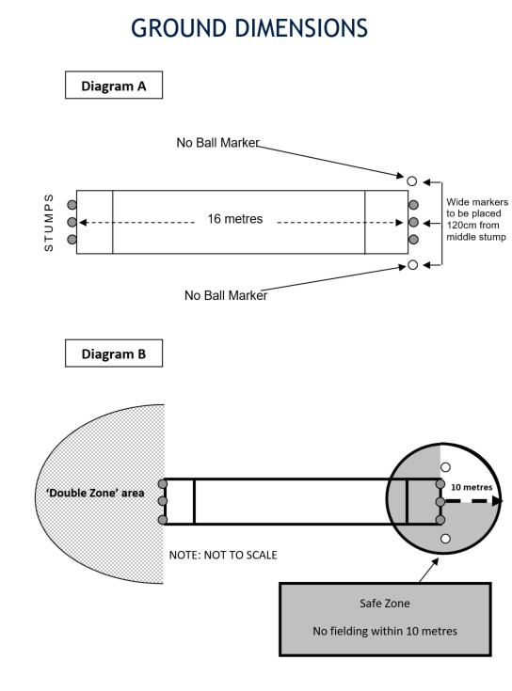

NB: This may need to be adjusted based on the space available, ensure all grounds within the same competition have the same field size.

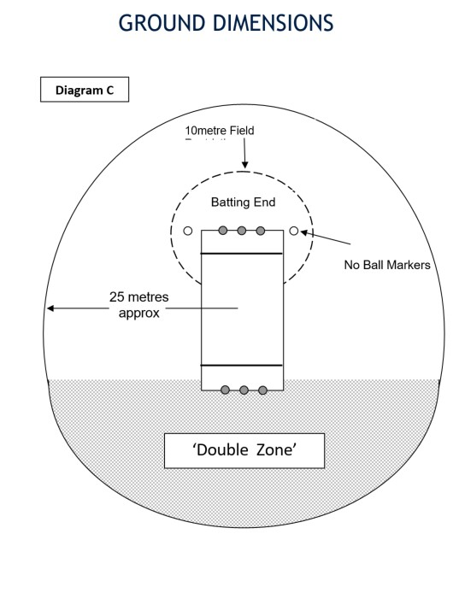

Crease: 1 stump length plus one foot length from the base of the stump.
Wide cones: One stump length to the left and right of the base of the stumps.
Around base of stumps.

