CORONAVIRUS
(COVID-19)

ATTENDANCE REGISTER

CHECK IN & OUT

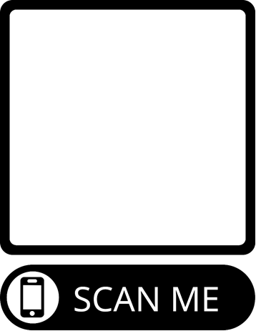

INSERT QR CODE HERE

- Open the Camera App on your phone
- Focus your camera on the QR code and wait for a box to appear at the top of your phone
- Go to the website that is opened on your phone.
- Complete your contact details
- Confirm your check-in
- Please remember to check out when you leave the facility by completing the same process.
Details collected will be destroyed after 28 days in line with DHHS requirements.

